

LI-FI BASED SECURE TEXT
DATA TRANSMISSION SYSTEM

A PROJECT REPORT PHASE-I

Submitted by

HARIESH A |  | (22EC023)
HARIHARAN T |  | (22EC025)
KUMAR T |  | (22EC046)

In partial fulfilment for the award of the degree
of

BACHELOR OF ENGINEERING

in

ELECTRONICS AND COMMUNICATION ENGINEERING

DEPARTMENT OF ELECTRONICS AND COMMUNICATION ENGINEERING
NANDHA ENGINEERING COLLEGE, ERODE-52

(Autonomous)

(Affiliated to Anna University, Chennai)

DECEMBER 2025

NANDHA ENGINEERING COLLEGE

(Autonomous)

(Affiliated to Anna University, Chennai)

BONAFIDE CERTIFICATE

Certified that this project report “LI-FI BASED SECURE TEXT DATA TRANSMISSION SYSTEM” is the bonafide work of “HARIESH A (22EC023), HARIHARAN T (22EC025), KUMAR T (22EC046)” Who carried out the project work under my supervision.

SIGNATURE Dr.R.Murugasami,M.E.,Ph.D., PROJECT SUPERVISOR
Department of ECE
Nandha Engineering College

Erode-52
SIGNATURE Dr.S.Kavitha,M.E.,Ph.D., PROFESSOR & DEAN Department of ECE
Nandha Engineering College

Erode-52

Submitted for the End semester Project Viva–Voce Examination held on --------

Internal Examiner External Examiner
ACKNOWLEDGEMENT

The success of a work depends on team effort and co-operation of various people involved either directly or indirectly.
We express our sincere thanks to our beloved Chairman of Sri Nandha Educational Trust Thiru.V.Shanmugan, and our beloved Secretary, Thiru.S.Thirumoorthi, of Nandha Engineering College for providing us all the basic amenities to complete the course successfully.
We wish to express our deep sense of gratitude and thanks to our beloved Principal Dr.U.S.Ragupathy, for the excellent facilities provided during the course study and project work.
We wish to express our hearty thanks to Dr.S.Kavitha, Professor & Dean, Department of Electronics and Communication Engineering for providing continuous support during the project work.
We are highly indebted to our project guide Dr.R.Murugasami, Associate Professor, Department of ECE, for his guidance and motivation in completing the project.
We would like to express our special thanks and gratitude to the Project Coordinators Dr.R.Murugasami, Associate Professor and Mr.T.Jayachandran, Assistant Professor, Department of ECE for providing effective suggestions and necessary information throughout the project work.
We thank all the Teaching and Non-Teaching staff members of Electronics and Communication Engineering Department for their support to our project work. We also express our thanks to our family members and friends for their encouragement, timely help and suggestions.

ABSTRACT

Secure and efficient data transmission is becoming increasingly important as traditional wireless technologies face challenges such as interference, hacking risks, and limited privacy. Existing wireless systems, especially RF-based communication, often suffer from susceptibility to noise, congestion in shared frequency bands, and weak security that makes data vulnerable to interception. Many basic Li-Fi models also lack strong encryption, have limited range, and do not perform well under varying light conditions. To address these issues, this proposal presents a Li-Fi-based secure text data transmission system designed to provide a reliable and confidential communication method using visible light. The system uses an ESP8266 NodeMCU at both the transmitter and receiver ends, along with a laser transmitter and receiver module, to send data through modulated light pulses. Before transmission, the text is encrypted using the AES algorithm to ensure protection from unauthorized access. The laser diode converts the encrypted data into optical signals, which are detected by the laser receiver and processed by another NodeMCU for decryption, after which the recovered message is shown on an LCD screen for accurate data retrieval. To ensure stable operation, the system includes components such as an LDR sensor for light detection, a regulated power supply, and alignment mechanisms to maintain a clear line-of-sight communication path. By combining secure encryption, optical wireless communication, and low-cost hardware, the proposed system provides a practical, interference-free, and highly secure method for short-range data transfer suited for various indoor applications requiring privacy and reliability.
This proposal supports SDG 9 (Industry, Innovation and Infrastructure) by promoting advanced and innovative communication technology through Li-Fi–based secure data transfer. It aligns with SDG 16 (Peace, Justice and Strong Institutions) by ensuring strong encryption and trustworthy communication that protects data privacy. Additionally, it contributes to SDG 7 (Affordable and Clean Energy) by using low-power laser-based transmission, making the system energy-efficient and sustainable.
TABLE OF CONTENTS

 | CHAPTER NO.  1 |  | TITLE  ABSTRACT  LIST OF FIGURES  LIST OF ABBREVIATION  INTRODUCTION |  | PAGE NO.  iv vii viii
 |  |  | 1.1 INTRODUCTION TO PROJECT WORK |  | 1
 |  |  | 1.2 EMBEDDED SYSTEM |  | 2
 |  |  | 1.3 OBJECTIVE |  | 2
 | 2 |  | LITERATURE SURVEY |  | 3
 | 3 |  | EXISTING SYSTEM
 |  |  | 3.1 BLOCK DIAGRAM AND DESCRIPTION |  | 10
 |  |  | 3.3 DRAWBACKS OF EXISTING SYSTEM |  | 11
 | 4 |  | PROPOSED SYSTEM
 |  |  | 4.1 BLOCK DIAGRAM |  | 14
 |  |  | 4.2 HARDWARE DESCRIPTION |  | 15
 |  |  | 4.2.1 ESP8266 NodeMCU |  | 15
 |  |  | 4.2.2 Laser Diode |  | 15
 |  |  | 4.2.3 LDR Sensor |  | 16
 |  |  | 4.2.4 LCD Display |  | 17
 |  |  | 4.3 SOFTWARE DESCRIPTION
 |  |  | 4.3.1 Arduino IDE |  | 17
 | 5 |  | RESULT AND DISCUSSION  5.1 LI-FI BASED SECURE TEXT TRANSMISSION |  | 19
 |  |  | 5.2 SDG MAPPING |  | 21
6 |  | CONCLUSION
 |  | 6.1 CONCLUSION |  | 22
 |  | 6.2 FUTURE SCOPE |  | 22
 |  | REFERENCES |  | 23

LIST OF FIGURES

FIGURE NO. | TITLE | PAGE  NO.
3.1 | Block Diagram of Existing System | 10
4.1 | Block Diagram of Proposed System | 14
4.2 | ESP8266 NodeMCU | 15
4.3 | Laser Diode | 15
4.4 | LDR Sensor | 16
4.5 | LCD Display | 17
4.6 | Arduino IDE | 18
5.1 | Li-Fi based secure text transmission | 19
5.2 | Encrypted data of the proposed system | 20

LIST OF ABBREVIATION

WORD ABBREVIATION
Li-Fi Light Fidelity
AES Advanced Encryption Standard
MCU Microcontroller Unit
LDR Light Dependent Resistor
PCB Printed Circuit Board
LED Light Emitting Diode
LCD Liquid Crystal Display
Tx Transmitter
Rx Receiver
CHAPTER 1

INTRODUCTION

  - INTRODUCTION TO PROJECT WORK

Li-Fi (Light Fidelity) is an emerging optical wireless communication technology that transmits data using visible light instead of traditional radio-frequency waves. With the rising need for secure, fast, and interference-free communication, Li-Fi offers a strong alternative due to its high bandwidth, immunity to electromagnetic interference, and suitability for indoor environments. By modulating light at high speeds, Li-Fi enables rapid transmission of digital information through laser or LED sources and detection through compatible receivers. The proposed system focuses on Li-Fi–based secure wireless text data transfer using a laser transceiver to achieve reliable and high-speed communication. An ESP8266 NodeMCU processes and encrypts the text using the AES algorithm and converts it into optical signals through a laser transmitter.
At the receiving end, a laser receiver captures the light signals, and another NodeMCU decodes and decrypts the message, which is then displayed on an LCD module for real-time viewing. The system ensures that the transmitted information remains confidential and protected throughout the entire communication process. This proposal demonstrates the benefits of Li-Fi technology, including low power usage, cost-effective hardware, high data speed, and resistance to electromagnetic interference. It highlights how light-based communication can address the limitations of traditional wireless systems and establishes a strong foundation for secure, short-range indoor communication applications. This makes the communication process safer and more reliable for everyday use. It also shows how simple components can work together to create an efficient and secure data transfer system.

1.2 EMBEDDED SYSTEM
An embedded system is a specialized computing system designed to perform a dedicated task within a larger device or application. Unlike general-purpose computers, embedded systems are optimized to operate with limited resources while maintaining high reliability, accuracy, and real-time performance. They integrate both hardware components such as microcontrollers, sensors, actuators, memory, and communication interfaces and software that controls how the system functions. The embedded software is programmed to execute specific operations with precise timing, making the system efficient and highly dependable. These systems operate continuously with minimal human interaction, providing automation and intelligent control in everyday devices.
Embedded systems are used in a wide range of applications due to their compact size, low power usage, and reliable performance. They are commonly found in household appliances, medical devices, automobiles, communication systems, and industrial machines. Modern embedded systems may also include features like wireless connectivity and smart control, making them more efficient and adaptable. As technology advances, embedded systems continue to play a key role in automation and intelligent device operation across various industries.

1.3 OBJECTIVE

The objective of the proposed system is to develop a secure Li-Fi–based wireless text transmission model using a laser transceiver to achieve fast, reliable, and interference-free communication. By integrating the Advanced Encryption Standard (AES) algorithm, the system ensures strong data confidentiality and protects transmitted text from unauthorized access. This project also aims to demonstrate the advantages of visible light communication, such as low power consumption, high data transfer speed, and immunity to electromagnetic interference. Additionally, the system focuses on providing a low-cost and efficient optical communication solution suitable for short-range applications, making it ideal for secure indoor environments and modern smart communication systems.
CHAPTER 2

LITERATURE SURVEY

2.1 Li-Fi Based Short Range Text Messenger
Li-Fi is an optical wireless communication technology that uses visible light for data transmission instead of radio waves like Wi-Fi. It offers higher speed, immunity to electromagnetic interference, and improved security because light cannot pass through walls. In this work, we demonstrate a simple Li-Fi text-transfer system using two Arduino boards. Text is entered through a 4×4 keypad, converted into light signals using an LED, and transmitted through free space. At the receiver, an LDR/photodiode detects the light variations and the Arduino decodes them back into text. This setup highlights the practicality, low cost, and efficiency of Li-Fi for short-range communication.

2.2 Next Generation High speed Data Transfer using Li-Fi-A Review

Li-Fi is an emerging wireless communication technology that uses visible light instead of radio waves to deliver very high data speeds. With growing demand for faster and more secure data transfer, Li-Fi provides advantages like large bandwidth, enhanced security, and immunity to electromagnetic interference. This review outlines how Li-Fi works, its potential for ultra-high-speed communication, and its use in indoor networks, smart devices, and secure environments. It also summarizes key components, benefits, challenges, and recent developments that make Li-Fi a strong candidate for future high-speed communication systems.

2.3 Exploring Li-Fi for IoT Advanced Audio Data Transfer

Li-Fi is an optical wireless technology that uses visible light for high-speed, low-latency, and secure data transmission. With growing IoT demands for fast and interference-free connectivity, Li-Fi offers an effective solution for reliable audio data transfer. Using LED transmitters and photodiode receivers, it supports high-quality audio streaming without electromagnetic interference, making it suitable for smart homes, healthcare, transportation, and industrial IoT.

2.4 Efficient Li-Fi based Tollgate System with Solar Power and Automation for Seamless Transactions

This concept presents a Li-Fi–based automated tollgate system powered by solar energy to improve vehicle processing efficiency. Unlike RFID or camera systems, Li-Fi enables precise point-to-point communication, ensuring toll data is exchanged only when the vehicle is correctly aligned, reducing false detections. Solar power makes the system suitable for remote highways, while automation handles vehicle identification, balance checking, and barrier control with minimal human involvement. The system also avoids signal overlap between lanes, ensuring accurate, lane-specific transactions. Overall, it offers a reliable, low-maintenance, and eco-friendly toll collection solution.

2.5 Technical features of building a Li-Fi network using SDN management methods

Using SDN to manage a Li-Fi network allows centralized and programmable control of all light-based access points, enabling dynamic management of LED power, modulation, traffic flow, and resource allocation. It ensures seamless handovers, load balancing, and prevents link drops as users move between Li-Fi zones. Real-time analytics support predictive adjustments and automated fault recovery when nodes face obstruction or failure. With features like network slicing and interference-aware control, SDN also makes integration with Wi-Fi, 5G, and wired networks easier, creating a flexible, scalable, and energy-efficient Li-Fi architecture.

2.6 Li-Fi technology based long range free-space communication data transmit system evaluation

Li-Fi–based long-range free-space communication evaluates how visible light can efficiently transmit data across long distances using high-intensity LEDs or laser diodes with photodiode receivers. It analyzes key factors like beam alignment, atmospheric interference, optical power, modulation, and receiver sensitivity that affect data rate and reliability. The system is tested under conditions such as fog, dust, and ambient light to study signal attenuation and error rates. By examining link budget, optical noise, and waveform quality, the study determines overall system feasibility. It concludes that with proper alignment and power control, Li-Fi can deliver high-speed, secure, and interference-free long-range connectivity.

2.7 Li-Fi Implemented Data Transfer
Li-Fi implemented data transfer uses visible light to transmit digital information, where an LED rapidly varies its intensity to encode data and a photodiode decodes it back into digital form. This approach enables fast, reliable, and interference-free communication over short to medium distances. It is well suited for device-to-device links, indoor networking, secure data exchange, and IoT applications. Using low-cost optical components and simple modulation schemes, Li-Fi efficiently supports text, sensor data, and multimedia transmission. Overall, it offers a practical alternative to radio-frequency communication for controlled environments.

2.8 Revolutionizing Data Transfer: Harnessing Li-Fi for Image and Text Transmission
Revolutionizing data transfer through Li-Fi uses visible light communication to transmit image and text data with high speed and reliability. LEDs modulate their light intensity to encode information, while photodiodes or light sensors decode the received signals. With high bandwidth and zero RF interference, Li-Fi enables faster and cleaner transmission than traditional wireless methods. It is ideal for secure indoor spaces, smart classrooms, medical environments, and IoT applications. By using efficient modulation and synchronization techniques, Li-Fi delivers sharp image data and error-free text transfer for next-generation communication systems.

2.9 Li-Fi Data Transmission Using Visible Light Communication Technology

Revolutionizing data transfer through Li-Fi uses visible light communication to transmit image and text data with high speed and reliability. LEDs modulate their light intensity to encode information, while photodiodes or light sensors decode the received signals. With high bandwidth and zero RF interference, Li-Fi enables faster and cleaner transmission than traditional wireless methods. It is ideal for secure indoor spaces, smart classrooms, medical environments, and IoT applications. By using efficient modulation and synchronization techniques, Li-Fi delivers sharp image data and error-free text transfer for next-generation communication systems.

2.10 Development of a Li-Fi System for Under Water Communications

The development of a Li-Fi system for underwater communication uses visible light as a high-speed alternative to acoustic or RF signals, which face heavy attenuation and low bandwidth in water. High-power blue or green LEDs transmit modulated light that carries digital data, while photodiodes or optical sensors detect and decode the signal at the receiver. Key factors include water clarity, scattering, precise alignment, and ambient light conditions. By optimizing optical power, modulation methods, and receiver sensitivity, the system supports fast, low-latency communication for underwater vehicles, diver tools, sensors, and IoT networks. This demonstrates Li-Fi’s ability to deliver efficient, short-range, high-bandwidth underwater communication.

2.11 Li-Fi Technology for Data and Voice Transmission

Li-Fi technology for data and voice transmission uses visible light communication to carry both digital information and real-time audio through high-speed LED modulation. LEDs encode data packets and voice signals into rapid light variations, while photodiodes decode them back into electrical signals at the receiver. With a wide spectrum and minimal interference, Li-Fi provides secure and directional links ideal for sensitive environments. By using suitable modulation, filtering, and synchronization techniques, it supports clear voice along with fast data transfer for applications in offices, hospitals, industry, and device-to-device communication. This shows Li-Fi’s strength as an efficient medium for combined voice and data in next-generation wireless systems.

2.12 Utilisation of Li-Fi Media for Toll-Tax Collection

Utilisation of Li-Fi media for toll-tax collection provides a fast, lane-specific, and interference-free method for vehicle identification and payment processing using visible light communication. Vehicles use Li-Fi transmitters to send encoded ID data, while receivers at the tollgate accurately capture the signals, preventing cross-lane mixing and reducing errors seen in RFID systems. The system supports instant authentication, automatic toll deduction, and smooth barrier operation without stopping the vehicle. It also lowers maintenance costs, reduces congestion, and works reliably even where RF communication struggles. Overall, Li-Fi offers a secure, precise, and efficient solution for modern toll automation.

2.13 IOT based smart agriculture using LIFI
IoT-based smart agriculture using Li-Fi combines visible light communication with sensor-driven farming to enable fast, reliable, and interference-free data exchange across fields. LEDs transmit real-time data from IoT sensors—such as moisture, temperature, humidity, and crop health—while photodiodes at receiving nodes decode and forward the information for analysis and automated control. Since Li-Fi is immune to electromagnetic interference, it works well around heavy machinery and sensitive equipment. It can also provide lighting and communication together, making it energy-efficient for greenhouses and controlled environments. Overall, this system improves decision-making, boosts crop yield, reduces resource wastage, and supports fully automated smart farming.

2.14 An Image Transmission Technique using Low-Cost Li-Fi Testbed

An image transmission technique using a low-cost Li-Fi testbed shows how visible light communication can efficiently send image data using simple and affordable components. High-brightness LEDs modulate light intensity to encode pixel information, while photodiodes or light sensors receive and decode the signal. Basic modulation and
synchronization methods ensure accurate image reconstruction even with limited hardware. By optimizing LED drive circuits, filtering, and sampling, the system achieves reliable image transfer with low distortion and minimal errors. This low-cost setup provides an accessible platform for students and researchers to experiment with optical communication and demonstrates Li-Fi’s potential for short-range multimedia transmission.

2.15 Baggage Theft Detection in Railways using Li-Fi Technology
Baggage theft detection in railways using Li-Fi uses visible light communication to securely monitor and track passenger luggage, preventing unauthorized movement or theft. Li-Fi transmitters in luggage compartments send unique ID signals to receivers in the coach, and any movement or tampering disrupts the link or triggers an updated signal for instant detection. The system sends alerts to a central unit for quick action by railway staff. Since Li-Fi’s directional light does not penetrate walls, each compartment can be monitored independently without interference from others, even in crowded environments. This provides accurate, real-time, and low-cost luggage security in railway systems.

2.16 Light-fidelity based biosignal transmission in bioelectronics and medical devices
Light-fidelity (Li-Fi) based biosignal transmission enables fast, secure, and interference-free communication of physiological data using visible light. LEDs or miniature optical emitters encode signals like ECG, EEG, EMG, oxygen levels, or glucose readings, while photodiodes decode them at the receiver. Since Li-Fi produces no electromagnetic radiation, it is ideal for medical environments with sensitive equipment. It supports real-time wireless monitoring from wearables, implants, and bedside devices without loss of signal quality. Because light cannot penetrate walls, Li-Fi also enhances data privacy, making it a strong option for next-generation medical electronics and smart healthcare systems.

2.17 Li-Fi: an emerging technology for health care
Li-Fi is emerging as a powerful healthcare technology, providing high-speed, secure, and interference-free communication using visible light. In hospitals with many wireless and sensitive medical devices, Li-Fi avoids electromagnetic interference while ensuring reliable data transfer. LEDs in patient rooms, ICUs, and operating theatres can provide both lighting and communication for real-time transmission of health records, sensor data, and medical images. Because Li-Fi signals stay within a room, patient data remains protected from unauthorized access.
2.18 PDA For Physically Impaired Using Li-Fi

A Personal Digital Assistant (PDA) for physically impaired individuals using Li-Fi enables fast, reliable, and contactless interaction through visible light communication. LEDs transmit modulated control signals that photodiodes in the PDA decode, allowing users with limited mobility to operate tools like wheelchairs, appliances, communication boards, and emergency systems without RF interference. Li-Fi provides secure, room-confined communication ideal for hospitals, rehabilitation centers, and smart homes. When combined with sensors, voice modules, or gesture inputs, it offers an efficient, low-cost assistive solution that enhances independence and quality of life for physically impaired users.

2.19 PC to PC file transfer using Li-Fi technology
PC-to-PC file transfer using Li-Fi enables high-speed and secure data exchange between two computers using visible light instead of Wi-Fi or cables. LEDs or laser diodes on one PC modulate light to encode file data, while a photodiode on the other PC receives and decodes it. With proper modulation, synchronization, and error correction, files like documents, images, and media can be transferred quickly and accurately over short distances. Since Li-Fi requires line-of-sight and cannot penetrate walls, the link stays isolated and protected from interference or unauthorized access. This provides a simple, low-cost method for short-range file sharing using basic optical components.

2.20 Li-Fi over Wi-Fi in internet data communication

Li-Fi over Wi-Fi in internet communication is a hybrid system that combines Li-Fi’s high-speed, interference-free light-based data transfer with Wi-Fi’s wide-area connectivity. Li-Fi delivers ultra-fast and secure localized communication using LED signals, while Wi-Fi ensures continuous access when the Li-Fi link is blocked or out of range. Integrating both technologies improves overall network performance by reducing congestion, enhancing security, and optimizing bandwidth use. This approach is especially useful in offices, labs, and smart buildings where reliable, high-speed indoor connectivity is essential.

CHAPTER 3

EXISTING SYSTEM

The existing systems used for visible-light data communication typically rely on simple LED–LDR–based transmission mechanisms, where data is encoded as light pulses and received using basic photodetectors. In these approaches, a keypad or user input device sends data to a microcontroller, which controls an LED to generate corresponding light pulses for transmission. At the receiver side, an LDR or similar light sensor detects these variations in light intensity and passes the signal to another microcontroller for decoding and display. Although this method enables low-cost wireless communication, it suffers from limitations such as slow data transfer speed, sensitivity to ambient light, lack of noise filtering, and limited communication distance. Moreover, existing implementations generally support only character-level transmission without providing features like error checking, data integrity validation, or secure communication. Figure 3.1 shows a block diagram of the existing system.

3.1 BLOCK DIAGRAM AND DESCRIPTION

KEYPAD
TRANSMITTED PULSE
TRANSMITTED (LED)
ARDUINO NANO
LDR SENSOR
ARDUINO UNO
LCD DISPLAY

Figure 3.1 Block Diagram of Existing System
The existing system was designed to enable low-cost, short-range data communication using visible light, where information is transmitted as light pulses and received through a photosensitive sensor. In this setup, a keypad is used as the primary input device, allowing the user to enter characters or commands. These inputs are processed by an Arduino Nano, which converts the data into a sequence of ON/OFF light pulses using an LED as the transmitter. The transmitted pulses travel through the visible-light channel and are detected by an LDR sensor at the receiver side, which senses variations in light intensity corresponding to the encoded data. The LDR output is then sent to an Arduino Uno, which decodes the received pulses back into readable characters. Finally, the decoded information is displayed on an LCD module for user visibility, as illustrated in Figure 3.1. Although this system provides a simple and cost-effective communication method, its performance is limited by ambient-light interference, slower response time of the LDR, and restricted transmission distance, making it suitable only for basic educational or experimental applications.

3.2 DRAWBACKS OF EXISTING SYSTEM

Limited Communication Range
Li-Fi-based communication systems commonly suffer from limited range because light cannot bend around obstacles. If the transmitter and receiver are not properly aligned, or if an object blocks the light path, the transmission becomes weak or fails entirely. This restricts the usability of existing Li-Fi solutions in practical environments where perfect line-of-sight cannot always be maintained.

Low Data Security in Basic Li-Fi Models
Many existing Li-Fi systems rely on simple or no encryption, making them vulnerable to eavesdropping when the light path is exposed. Without strong cryptographic techniques, these systems fail to provide secure communication, especially in applications where confidentiality and authentication are critical.

High Sensitivity to Ambient Lighting
Most current Li-Fi prototypes perform poorly under strong ambient light conditions. Sunlight, fluorescent lamps, and reflective surfaces may interfere with the optical signals, resulting in data loss or reduced accuracy. This makes traditional Li-Fi designs less reliable for outdoor or brightly lit environments.

Lack of Adaptive Modulation Techniques
Existing Li-Fi models often use fixed modulation schemes that cannot adapt to varying transmission conditions. Without adaptive algorithms or error-correction methods, these systems may struggle with signal distortions, noise, and fluctuations, leading to inconsistent performance and reduced reliability.

Limited Hardware Efficiency and High Power Consumption
Some earlier Li-Fi systems use bulky or power-hungry components such as high-intensity LEDs or traditional photodiodes. This increases the overall cost and makes the system less suitable for low-budget users or portable applications. Lack of optimized hardware limits the scalability of such systems.

Insufficient Real-World Testing and Validation
Many Li-Fi-based text transmission systems are confined to laboratory experiments and lack real-world performance validation. Without practical testing under different lighting conditions, distances, and environmental challenges, their effectiveness and reliability in real applications remain uncertain.

CHAPTER 4

PROPOSED SYSTEM

The proposed system presents a secure, reliable, and energy-efficient Li-Fi–based text communication model that utilizes visible light instead of traditional radio waves for data transmission. By integrating an ESP8266 NodeMCU with a laser transceiver module, the system ensures high-speed optical communication capable of overcoming common RF limitations such as interference, congestion, and weak privacy. At the transmitter unit, the user inputs text data, which is processed by the ESP8266 NodeMCU, where the Advanced Encryption Standard (AES) is applied to convert the plain text into secure encrypted data. The encrypted information is then modulated into high-speed light pulses using a laser diode, enabling fast and accurate communication through a direct line-of-sight optical channel.
On the receiver end, a laser receiver module detects the incoming modulated light and converts it back into electrical signals. These signals are then processed by another ESP8266 NodeMCU, which performs demodulation and AES decryption to retrieve the original message. The recovered text is displayed on an LCD screen for real-time user readability. To maintain stable operation, the system incorporates components such as an LDR sensor for improved light detection, a regulated power supply for consistent operation, and alignment mechanisms to sustain a clear optical path between transmitter and receiver.
This proposed system offers a low-cost and energy-efficient communication solution that eliminates electromagnetic interference and enhances data confidentiality. Compared to traditional RF-based systems, Li-Fi provides improved privacy, as optical signals do not penetrate walls, making unauthorized interception more difficult. With encryption ensuring secure data handling and visible-light communication providing high-speed performance, the system demonstrates strong potential for modern short-range indoor communication applications requiring reliability and privacy.

4.1 BLOCK DIAGRAM

INPUT
MESSAGE
ESP8266 NodeMCU
LASER TRANSMITTER
LCD DISPLAY
ESP8266 NodeMCU
LDR
RECEIVER

Figure 4.1 Block Diagram of Proposed System

The block diagram of the proposed Li-Fi based secure text transmission system, shown in Figure 4.1, illustrates the flow of data from the transmitter side to the receiver side using visible light communication. At the transmitter, the user enters text, which is processed by the ESP8266 NodeMCU. Before transmission, the text is encrypted using a secure algorithm to ensure confidentiality, after which the encrypted data is converted into modulated light pulses and transmitted through a laser transmitter module. On the receiver side, a laser receiver module detects the incoming light signals and converts them back into electrical signals. The received data is then fed into another ESP8266 NodeMCU, where it is demodulated and decrypted to retrieve the original message. The final output is displayed on an LCD screen. The system ensures secure, low-cost, and interference-free communication using light instead of radio-frequency signals, making it suitable for short-range data transmission applications.

4.2 HARDWARE DESCRIPTION

4.2.1 ESP8266 NodeMCU

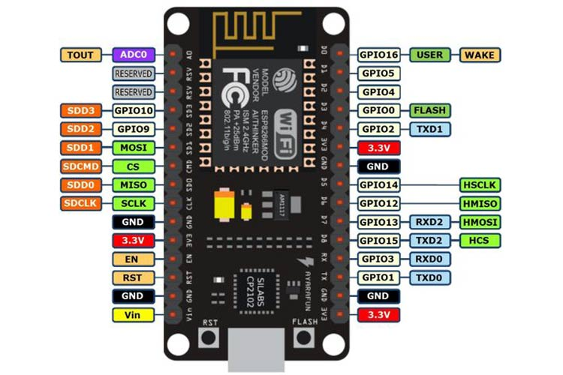

Figure 4.2 ESP8266 NodeMCU

The ESP8266 NodeMCU, shown in Figure 4.2, functions as the main controller in both the transmitter and receiver sections of the proposed Li-Fi system. It processes the input text, encrypts it using the AES algorithm, and converts the data into digital signals to drive the laser diode for optical transmission. On the receiver side, the NodeMCU reads the electrical output from the laser sensor, demodulates the signal, and decrypts the data to restore the original message. It then sends the recovered text to the LCD module for display. Through its efficient processing and interfacing abilities, the NodeMCU ensures secure and reliable communication.

4.2.2 LASER DIODE

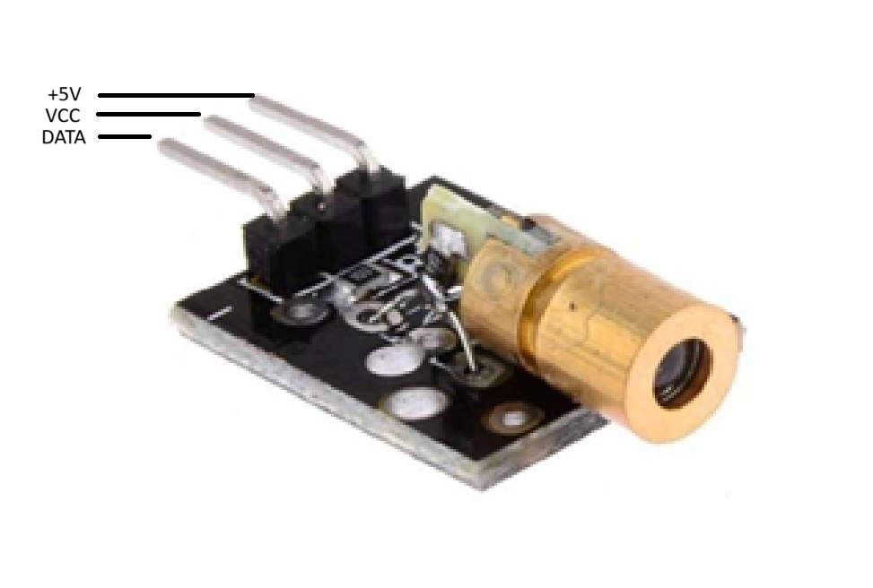
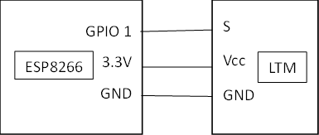

Figure 4.3 Laser diode

The laser diode, shown in Figure 4.3, is a key component in the proposed Li-Fi system, responsible for converting encrypted electrical data into high-speed optical signals. It emits a focused and coherent beam of light that can be rapidly modulated to represent digital information. This enables accurate transmission of text data through a direct line-of-sight optical channel. Due to its efficiency and precision, the laser diode ensures stable and fast communication. Its compact size and low power consumption make it ideal for secure short-range data transmission applications. It works very quickly, allowing messages to be sent almost instantly. Because it uses light instead of wires, it helps make the whole system simple and efficient.

4.2.3 LDR SENSOR

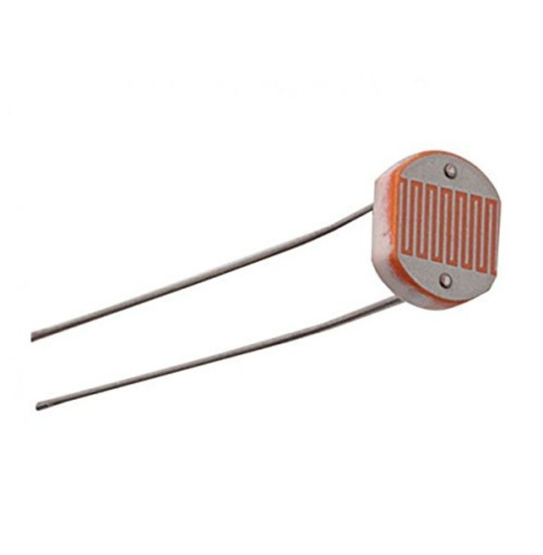
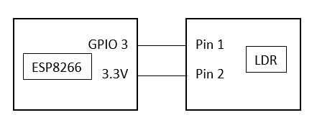

Figure 4.4 LDR sensor

The LDR sensor, shown in Figure 4.4, plays an important role in the proposed Li-Fi system by detecting variations in light intensity. It changes its resistance based on the amount of light falling on it, allowing the system to identify incoming optical signals accurately. This enables the receiver section to interpret the modulated light pulses transmitted by the laser diode. Due to its sensitivity and quick response, the LDR supports stable data detection in short-range communication. Its low cost and simple interfacing make it a suitable component for light-based communication systems. It helps the system “see” the light signals clearly so the message can be understood correctly. Because it is easy to use, it allows beginners to work with Li-Fi technology without difficulty.

4.2.4 LCD DISPLAY
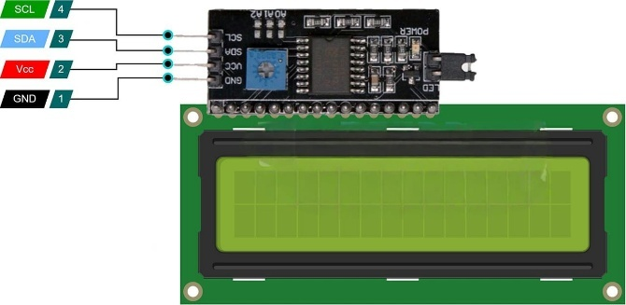
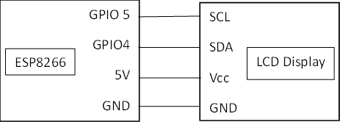

Figure 4.5 LCD Display

The LCD display, shown in Figure 4.5, is used in the proposed Li-Fi system to present the received and decrypted text message clearly to the user. It provides a simple interface for viewing data in real time, ensuring that the transmitted information is accurately displayed. The LCD operates using an I2C interface, which reduces the number of required connections and simplifies communication with the ESP8266 NodeMCU. Its low power consumption and reliable performance make it suitable for embedded applications. Overall, the LCD display enhances the usability and readability of the communication system.

4.3 SOFTWARE DESCRIPTION

4.3.1 Arduino IDE

The Arduino IDE (Integrated Development Environment), shown in Figure 4.6, is a user-friendly software platform used for writing, compiling, and uploading code to Arduino and compatible microcontroller boards. It supports a simple programming language based on C/C++, making it easy for beginners to learn and experiment with embedded systems. The IDE includes a code editor, serial monitor, and a wide range of built-in libraries that simplify interfacing with sensors, displays, and communication modules. It also allows developers to manage board settings and install additional packages for boards like ESP32 and ESP8266. Due to its simplicity, portability, and extensive community support, Arduino IDE is widely used for prototyping, IoT projects, and educational purposes.
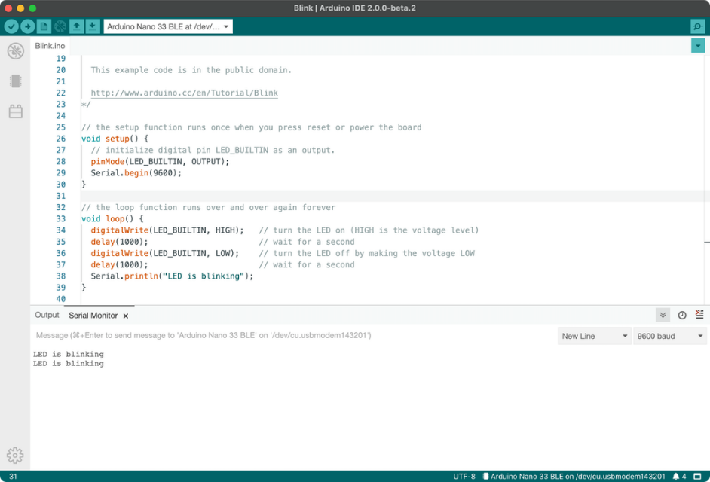

Figure 4.6 Arduino IDE

CHAPTER 5

RESULT AND DISCUSSION

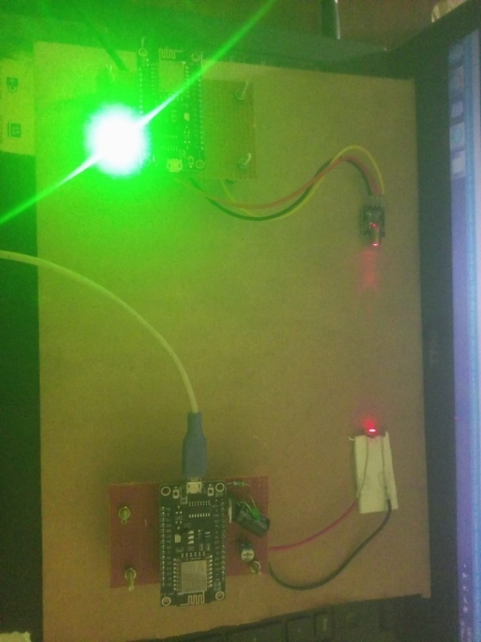
5.1 LI-FI BASED SECURE TEXT TRANSMISSION

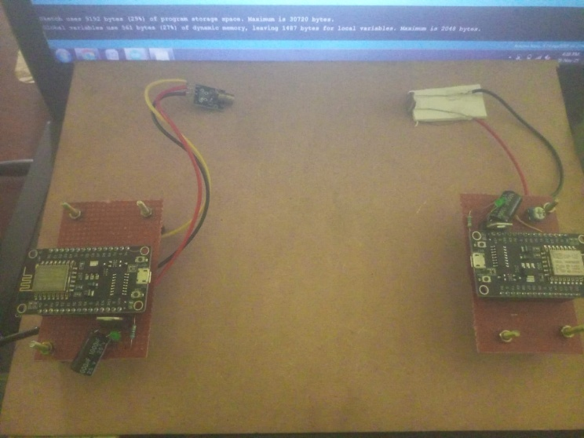

Figure 5.1 Li-Fi based secure text transmission

Figure 5.1 shows the experimental setup, which successfully demonstrated Li-Fi–based text transmission between two NodeMCU (ESP8266) modules using a laser transmitter and LDR receiver. The transmitter encoded the data into light pulses, while the receiver accurately detected and decoded the signals, confirming reliable one-way communication. The system performed well under proper alignment, exhibiting low noise and minimal data loss during short-range transmission. However, slight misalignment or ambient light affected the receiver sensitivity, emphasizing the need for proper focusing and shielding. Overall, the prototype demonstrated that low-cost components can deliver effective optical communication, validating Li-Fi as a secure and interference-free alternative for data transfer. This setup also shows strong potential for future improvements in range, speed, and stability.

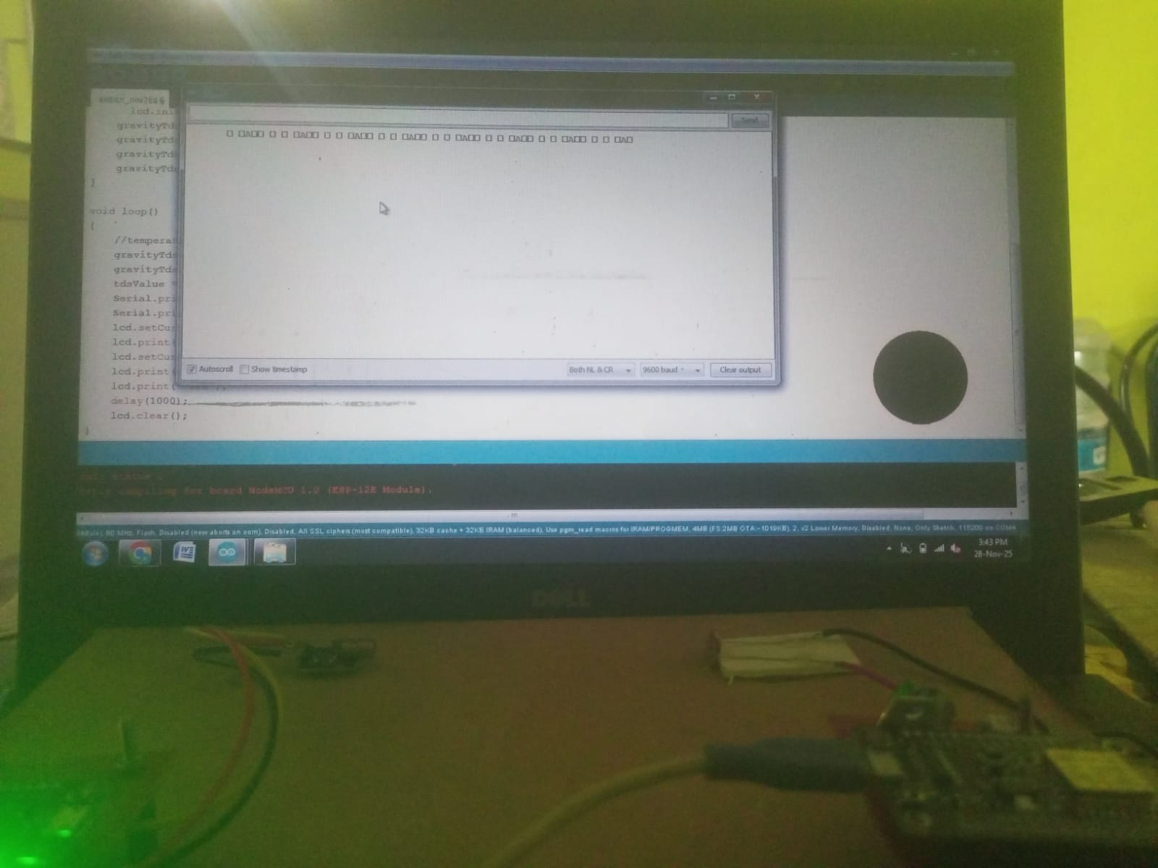

Figure 5.2 Encrypted data of the proposed system

Figure 5.2 shows the serial monitor output, confirming that the transmitter NodeMCU is successfully sending encrypted data through the Li-Fi communication link. Each character or symbol displayed in the serial window represents the decoded optical signal, which was first encrypted at the transmitter and then decrypted at the receiver after being captured by the photodiode. The transmitter converts the encrypted text or binary data into rapid ON–OFF light pulses using the laser/LED, ensuring that the transmitted information remains secure even if intercepted. The receiver detects these variations, decrypts the received data, and reconstructs it into readable digital form. The repeated patterns in the output indicate continuous and stable encrypted data transmission, demonstrating proper alignment, synchronization, and functioning of both modules. Thus, Figure 5.2 clearly proves that the Li-Fi transmitter is actively sending encrypted data and the receiver is successfully decoding it in real time, ensuring secure and reliable optical communication.

5.2 MAPPING OF SDG WITH PROPOSED SYSTEM

SDG 7: Affordable and Clean Energy


Li-Fi uses visible light, which is energy-efficient and can be powered using low-power electronic components. This reduces energy consumption compared to conventional wireless technologies, supporting the goal of clean and efficient energy use.

SDG 9: Industry, Innovation and Infrastructure


The project promotes innovative communication technology by using Li-Fi and ESP8266 NodeMCU, offering a secure and modern alternative to conventional wireless systems.

SDG 16: Peace, Justice and Strong Institutions



By implementing AES encryption, the system ensures secure and confidential data transfer, strengthening digital safety and supporting trusted communication practices.
CHAPTER 6

CONCLUSION

6.1 CONCLUSION

The Li-Fi Based Secure Text Data Transmission System demonstrates an effective and innovative approach to short-range wireless communication using visible light. By integrating the ESP8266 NodeMCU with laser-based Li-Fi technology, the system successfully transmits text data with high speed, low interference, and improved reliability. The use of AES encryption ensures strong data confidentiality, making the communication secure against unauthorized access. The hardware components, including the laser transmitter, laser receiver, LDR sensor, and LCD module, work together to create a low-cost and energy-efficient communication model. This project highlights the potential of Li-Fi as a practical alternative to traditional RF technologies, especially in environments where security and interference-free communication are essential. Overall, the system provides a promising foundation for future advancements in secure optical communication and opens opportunities for further research and real-world applications.

6.2 FUTURE SCOPE

The proposed system demonstrated how data can be encrypted and securely transmitted using Li-Fi, but future work can include implementing stronger encryption methods to enhance security even further. Additional improvements like increasing range, reducing noise, and enabling two-way communication can make the system more efficient and practical for real-world applications.

REFERENCES

[1] Krishna, A., Anand, P., Varshney, Y., Kumar, P., & Antony, S. M. (2023). “Li-Fi Based Short Range Text Messenger”. Journal of Optoelectronics and Communication, 5(2).
[2] Manhas, P., Kathpal, N., Kumar, M., & Choudhary, U. (2024). “Next Generation High speed Data Transfer using Li-Fi-A Review”. International Conference on Sustainability and Technological Advancements in Engineering Domain (SUSTAINED) (pp. 367-370).
[3] Khaleel, B. M., Alatba, S. R., Hamdoun, S. H., & Terenchuk, S. (2024). “Exploring Li-Fi for IoT Advanced Audio Data Transfer”. Conference of Open Innovations Association (FRUCT) (pp. 343-351).

[4] Kamesh, G. and Vishnu, V. (2024). “Efficient Li-Fi based Tollgate System with Solar Power and Automation for Seamless Transactions”. International Conference on Communication and Electronics Systems (ICCES) (pp. 290-294).
[5] Romanov, O., Burlaka, H., Berestovenko, O., & Pidpaly, O. (2023). “Technical features of building a li-fi network using SDN management methods” (3), 16-25.
[6] Faruq, O., Shahriar Rahman, K. R., Jahan, N., Rokoni, S., & Rabeya, M. (2023). “Li-Fi technology based long range free-space communication data transmit system evaluation”. International Review of Applied Sciences and Engineering, 14(3), 413-425.
[7] Joshi, A. S., Kulkarni, A., Mundhe, A., Joshi, A., Kothawade, A., & Tyagi, A. (2023, February). “Li-Fi Implemented Data Transfer”. In 2023 IEEE 3rd International Conference on Technology, Engineering, Management for Societal impact using Marketing, Entrepreneurship and Talent (TEMSMET) (pp. 1-4).
[8] Dhanasekaran, D., ML, R. P., & Muniyappan, R. (2023, November). “Revolutionizing Data Transfer: Harnessing Li-Fi for Image and Text Transmission”. In 2023 7th International Conference on Electronics, Communication and Aerospace Technology (ICECA) (pp. 1501-1505).
[9] Sirohi S, Kumari P, Arya J, Kumar A, Kumar P, (2023). “Li-Fi Data Transmission Using Visible Light Communication Technology”. In 2023 3rd International Conference on Advancement in Electronics & Communication Engineering (AECE) (pp. 43-45).

[10] Lata, Y.R., Gusain, R., Shekhar, S., Vidyarthi, A., Prakash, R. and Gowri, R., (2023), December. “Development of a LiFi System for Under Water Communications”. In 2023 9th International Conference on Signal Processing and Communication (ICSC) (pp. 99-102).

[11] Ubale, Jaydip, Pragati Nagrale, Aaditya Kakpure, and C. R. Kuwar, (2023). “Li-Fi Technology for Data and Voice Transmission”.

[12] Arya, Dinkar, Vaibhav Aher, and Gaurav Shinde, (2022) “Utilisation of Li-Fi Media for Toll-Tax Collection”. International Journal of Optical Sciences 8, no. 2: 37-41.

[13] Vijayakrishna, A., Gopichand, G., Ansari, M. D., & Suryanarayana, G. (2022). “IOT based smart agriculture using LIFI”. In 2022 5th International Conference on Multimedia, Signal Processing and Communication Technologies (IMPACT) (pp. 1-7).
[14] Salvi S, Geetha V, Maru H, Kumar N, Ahmed R, (2021). “An Image Transmission Technique using Low-Cost Li-Fi Testbed”. In 2021 2nd International Conference on Secure Cyber Computing and Communications (ICSCCC) (pp. 114-119).

[15] Mudakavi, C.S., Sajjan, S.B., Shreyas, S.R. and Shetty,V., (2020). “Baggage Theft Detection in Railways using Li-Fi Technology”.
[16] Patnaik PK, Nayak SK, Pradhan A, Bhattacharya C, Ray SS, Pal K, (2019). “Light-fidelity based biosignal transmission”. In Bioelectronics and Medical Devices (pp. 1-14). Woodhead Publishing.
[17] Pandiyan M, Revathi CS (2019). “Li-Fi: an emerging technology for health care”. Asian Journal of Computer Science and Technology. 8(S1):38-40.
[18] Prabhavathi S, (2018). “PDA For Physically Impaired Using Li-Fi”. International Journal of Recent Research Aspects.
[19] Shakeera, S., Manideep, P. S., Begum, M. S., Bhargav, V. V., & Rao, P. D. N. M. (2017). “PC to PC file transfer using Li-Fi technology”. International Journal of Engineering Trends and Technology (IJETT), 45(3), 143-145.
[20] Miteku N. (2015). “Li-Fi over Wi-Fi in internet data communication”. International Journal of Advanced Research in Computer and Communication Engineering (IJARCCE), 3(12), 153-159.

